**The problem**

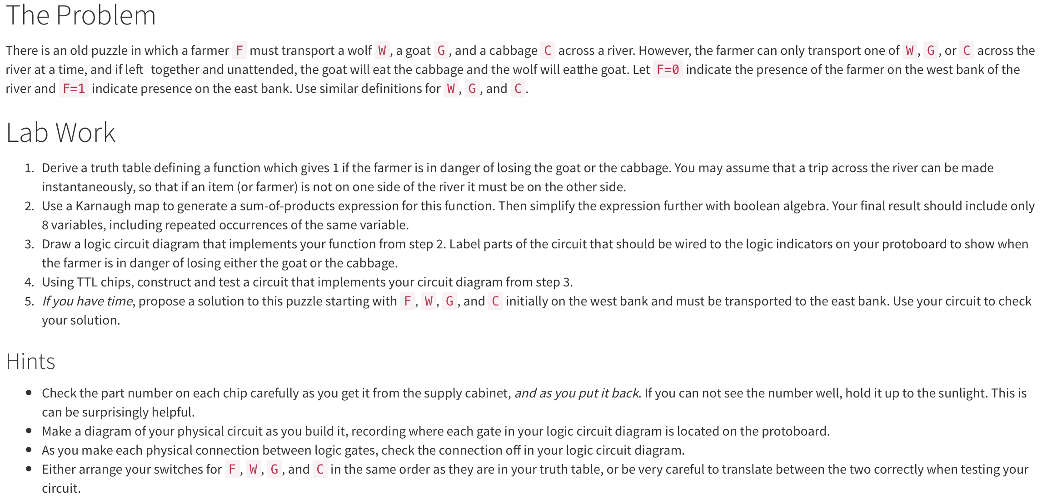

Farmer legal moves truth table

0=on left, 1=on right (note:position representation is NOT same as what answer representes)

takesWolf

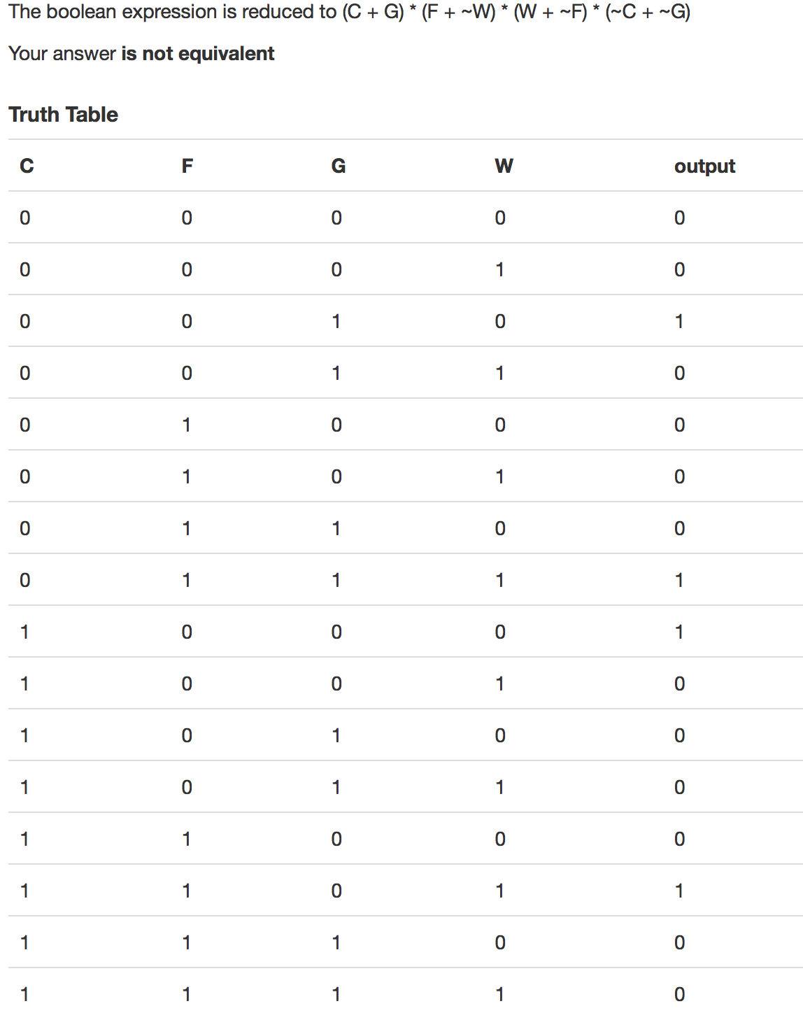

**takesGoat**

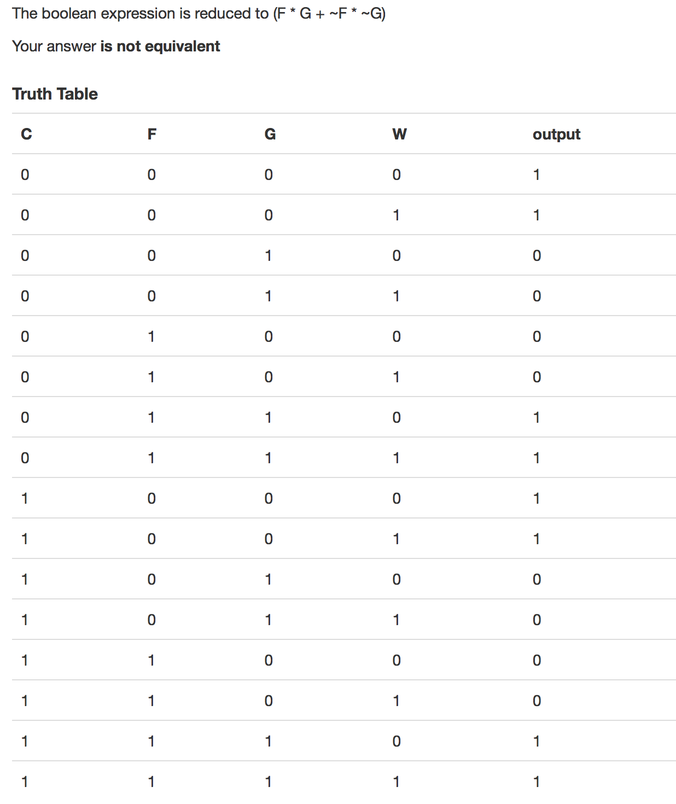

Takes Cabbage

